**CHAPTER NO.01**

**INTRODUCTION**

1. **INTRODUCTION**

**1.1 Background**

Struts and shock absorbers lose their ability to buffer road bumps as they are used, and their damping ability eventually diminishes to a point requiring their replacement. The usual method by which the end of service life of shock absorbers is judged is for a mechanic to push down on the vehicles hood or trunk and watch the dynamic response when the force is abruptly removed. The criterion for determining whether to replace shocks is based upon expert knowledge of the mechanic. The proposed device would enable quantitative (rather than qualitative) measurement of dynamic response of a vehicle’s suspension system and put an objective basis behind the decision when to replace shock absorbers and struts.

There are different components that make the automobile performance reliable and secure for the driver. Even though the customer is attracted to how powerful the car is or how fast it can go, it would be nothing if the driver couldn’t control the car. That is why a reliable suspension system is crucial in the engineering of a vehicle. The important tasks that this systems should accomplish is to support the vehicle weight, isolate the body from the vibrations caused by the unevenness of the road and keep a firm contact between the tires and the road. Most suspension systems are composed of springs and dampers which limit the systems performance due to their physical constraints. To resolve these problems different types of suspension systems have been created. A key element in any vehicle suspension system is the shock absorber. It plays a vital role in the vertical and horizontal motion of the vehicle. The accuracy of the vehicle model is highly dependent on the accuracy of the shock absorber model. The shock absorber is also one of the most non-linear and complex suspension system elements to model. There are two approaches to model shock absorbers: physical modelling based on physical and geometrical data, and nonparametric modelling based on experimental data. Each of them has particular advantages and disadvantages.

The shock absorber (spring and damper) suspension system that uses a force sensor to measure the impact force (F**0**) and transmitted force (Ft) and then take its ratio which is known as ‘force transmissibility’ with the use of electronic equipment.

With the use of electronic circuits, the system will analyse the shock absorber characteristics. In effect, the vehicle’s body will stay at the same vertical position at all times regardless of the road conditions. The experimental setup record output speed of the gearbox which is driven by the 0.5H.P, D.C motor. This speed is important for plotting force transmissibility vs. frequency ratio.

* 1. **Objectives**
* A system used to determine the force impressed and force transmitted and hence force transmissibility i.e. ratio of (Ft / F0).
* Main objective of this system is to plot the force transmissibility vs. frequency ratio (variable rpm) curve at various damping condition as well as at various amplitudes.
* Damping characteristics of the suspension of a light weight automobile, minivan, two wheelers, including characterization of the status of shock absorbers.
* The cost must be sufficiently low to be attractive to individuals who do their own automotive work in industries as well as garages.

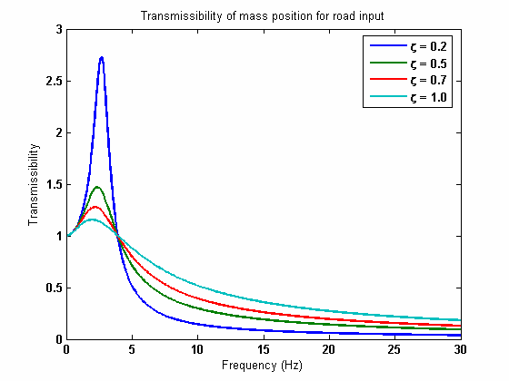

**Figure 1.1: Transmissibility vs. Frequency**

**CHAPTER NO.02**

**THEORY**

1. **THEORY**

Assuming that the forcing function is harmonic in nature, we shall consider two cases of vibration transmission - one in which force is transmitted to the supporting structure, and one in which the motion of the supporting structure is transmitted to the machine.

**2.1 Force Excitation**

Consider the system shown in Figure 2.1, where (*F0*sinɷt) is the harmonic force acting on the system and *f****T****(t)* is the force transmitted to the supporting structure or base.

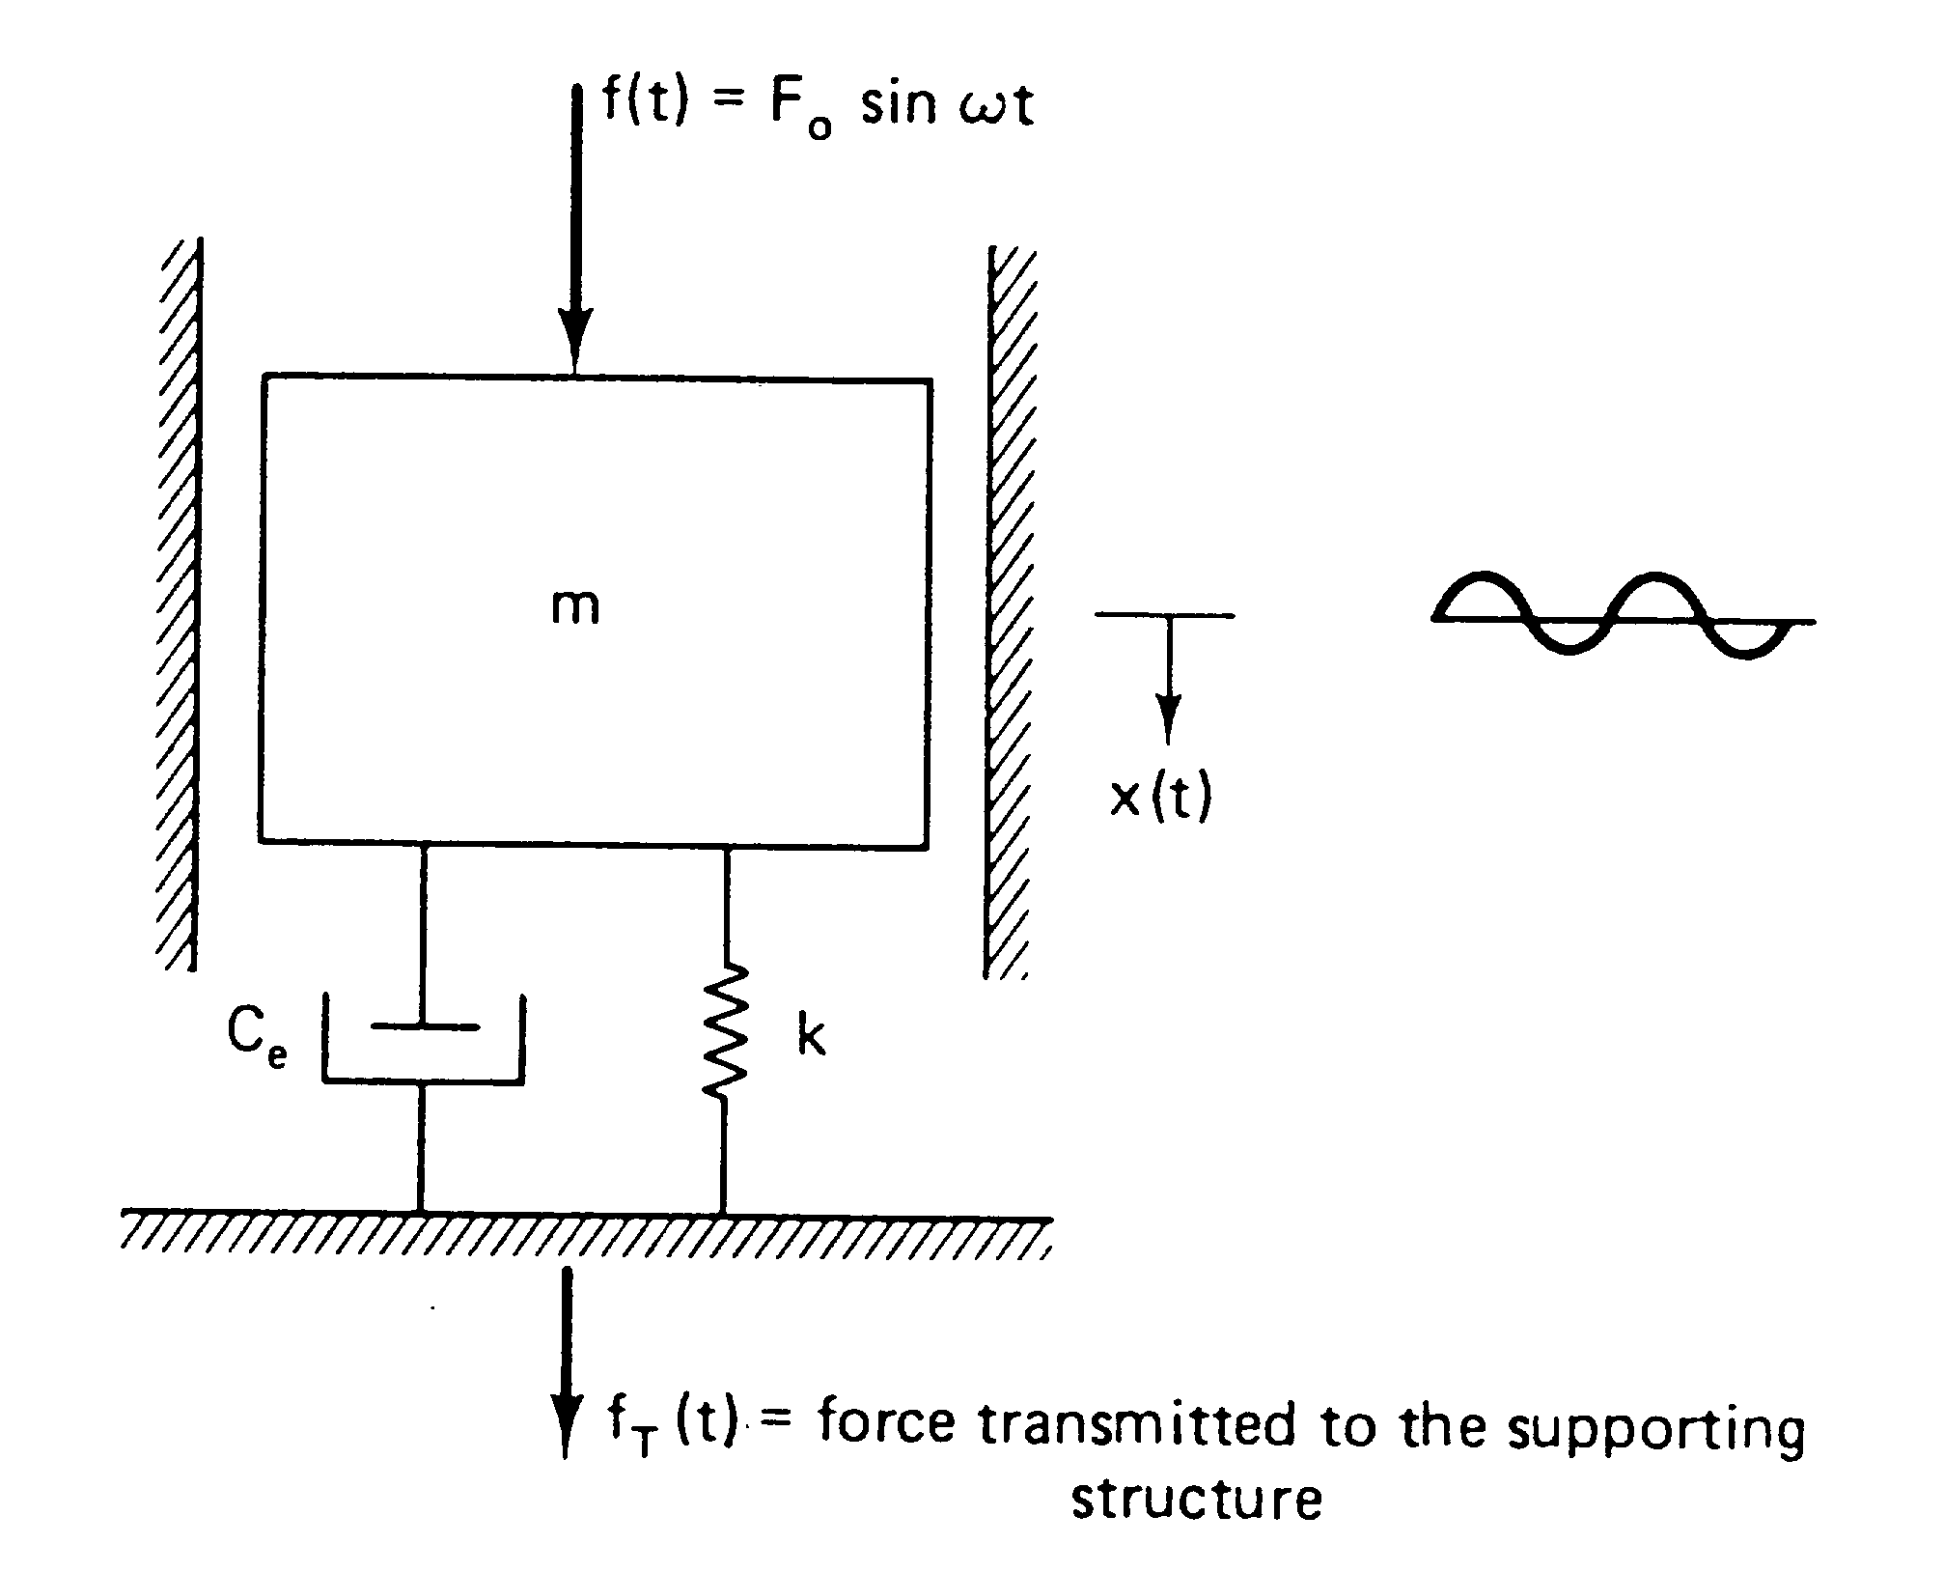

**Figure 2.1: Concept for constructing shock absorber testing models**

The force impressed through the spring and damper to the supporting structure is given by:

$$m\ddot{x}+c\dot{x}+mx=f_{0}sinωt$$

Where, m = mass of the system

c = damping coefficient

ɷ = circular frequency of external excitation force.

* 1. **Transmissibility**

T is defined as the *transmissibility* and represents the ratio of the amplitude of the force transmitted to the supporting structure to that of the exciting force.

$$T=\frac{F_{T}}{F_{0}}=\sqrt{\frac{1+{\left[2ζ\left(\frac{ω}{ω_{n}}\right)\right]}^{2}}{{\left[1-{\left(\frac{ω}{ω_{n}}\right)}^{2}\right]}^{2}+{\left[2ζ\left(\frac{ω}{ω_{n}}\right)\right]}^{2}}}$$

FT = force transmitted, N

F0 = induced force, N

ζ = damping ratio

$ω$ = frequency of induced force, Hz

${ ω}_{n}$ = natural frequency of system = 2πfn, Hz

Therefore,

$${ f}_{n}=\frac{1}{2π}\sqrt{\frac{k}{m}}$$

Also, ζ = $\frac{c}{c_{c}}$ = damping ratio

There is one more concept that should be understood before introducing the damping curve – the concept of transmissibility. Motion transmissibility is defined as the ratio between output and input amplitude. In our application, the input amplitude will be the height of a road irregularity and the output amplitude is the vertical movement of the vehicle body. For a spring-mass-damper system, transmissibility is actually a function of frequency. Whether you realize it or not, most of you actually know this already from driving cars on the street. We all know that if you hit a speed bump going very slowly, the car moves vertically almost as much as the wheels. But if you were to go over the same bump going quickly, the body of the car doesn’t move nearly as much. Depending on the speed at which you hit the speed bump, the car body’s response changes. The cause of this phenomenon is that the response of the system – the vehicle and its suspension – is a function of the frequency of the input.



**Figure 2.2: Transmissibility vs. Frequency**

* 1. **Damping**

A term broadly used to denote either the [dissipation](http://www.answers.com/topic/dissipation) of energy in or the consequent decay of oscillations. The energy losses arise from frictional (or analogous) forces which are [unavoidable](http://www.answers.com/topic/unavoidable) in any system or from the radiation of energy to space or to other systems. For sufficiently small oscillations, the analogous forces are proportional to the velocity of the vibrating member and oppositely directed [thereto](http://www.answers.com/topic/thereto); the ratio of force to velocity is *R*, the mechanical resistance. For the role of damping in the case of forced oscillations, where it is decisive for the frequency response, [Forced oscillation](http://www.answers.com/topic/forced-oscillation); [Resonance (acoustics and mechanics)](http://www.answers.com/topic/resonance); [Harmonic motion](http://www.answers.com/topic/harmonic-motion-2); [Mechanical vibration](http://www.answers.com/topic/mechanical-vibration).

In physics, damping is an effect that reduces the amplitude of oscillations in an oscillatory system (except for mass-dominated systems where √2), particularly the harmonic oscillator. This effect is linearly related to the velocity of the oscillations. This restriction leads to a linear differential equation of motion, and a simple analytic solution.

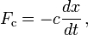

Where, c is the viscous damping coefficient, given in units of Newton seconds per meter (N-s/m) or simply kilograms per second. In engineering applications it is often desirable to linearize non-linear drag forces. This may by finding an equivalent work coefficient in the case of harmonic forcing. In non-harmonic cases, restrictions on the speed may lead to accurate linearization.

Generally, damped harmonic oscillators satisfy the second-order differential equation:

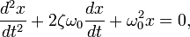

Where, ω0 is the undamped angular frequency of the oscillator and ζ is a constant called the damping ratio.

The value of the damping ratio ζ determines the behaviour of the system. A damped harmonic oscillator can be:

* *Overdamped* (*ζ* > 1): The system returns ([exponentially decays](http://www.answers.com/topic/exponential-decay)) to equilibrium without oscillating. Larger values of the damping ratio *ζ* return to equilibrium slower.
* *Critically damped* (*ζ* = 1): The system returns to equilibrium as quickly as possible without oscillating. This is often desired for the damping of systems such as doors.
* *Underdamped* (0 < *ζ* < 1): The system oscillates (at reduced frequency compared to the *undamped* case) with the amplitude gradually decreasing to zero.
* *Undamped* (*ζ* = 0): The system oscillates at its natural resonant frequency (*ω*o).

The [damped natural (angular) frequency](http://www.answers.com/topic/vibration-4) *ω*d, i.e., the frequency the oscillation occurs when the system is underdamped (0 < *ζ* < 1) and under free vibration, with regards to the damping factor *ζ* and the undamped natural (angular) frequency *ω*0 is given by:



This is not to be confused with the [resonant](http://www.answers.com/topic/resonance-quantum-mechanics) frequency *ω*peak. This is the frequency at which a moderately underdamped (*ζ* < 1/ $\sqrt{2}$) simple 2nd order harmonic oscillator has apeak gain (or peak [transmissibility](http://www.answers.com/topic/transmissibility-vibration)) when driven by a [sinusoidal](http://www.answers.com/topic/sine-wave) input. The frequency at which this occurs is given by:



**2.3.1 Damping Ratio (ζ**)

The damping ratio, usually designated as ζ, is defined as the ratio of actual damping coefficient to the critical damping coefficient. The reason why we work with damping ratios instead of actual damping coefficients is so that we can normalize the discussion for all dampers. Choosing a damping ratio is a generally a trade-off between response time and overshoot (you want to minimize both). Typically, passenger cars will use a damping ratio of around 0.25 to maximize ride comfort. For a race-car, the damping must be considerably higher for road holding and control of the unsprung mass motion. Data has shown that for race-cars, a good baseline for damping ratio is between 0.65 and 0.70. Generally damping ratio is given by,

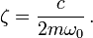

Where,

C: damping coefficient of damper in spring-mass damper system

m: mass of system

ω0: natural frequency

Transmissibility also changes with damping. Included below is a plot of the transmissibility of a spring-mass-damper system for various damping ratios. For maximum grip, we want to minimize the change in forces that the springs are seeing. This is achieved with minimal body movement. Thus, we want the lowest transmissibility possible. At low frequencies, you can see from the plot that we want higher damping ratios. However, the trade-off occurs after the crossover frequency, throughout which we would like a lower damping ratio. Corresponding low frequencies to low shock speeds, and high frequencies to high shock speeds, you can see that we need high damping ratios for low speeds and low damping ratios for high speeds. This concept will be used in determining baseline damper curves.

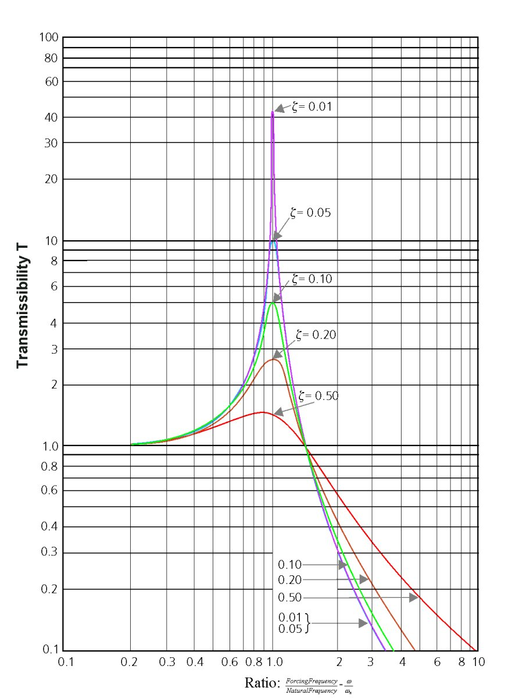

**Figure 2.3: Typical transmissibility curves plotted against frequency ratio with varying damping ratios**

* 1. **Dynamic Characterization**

Lastly, in order to determine the effectiveness and usability of these mounts, one must employ the concept of base excitation and displacement transmissibility. The displacement transmissibility is defined as the ratio of the displacement of a mass resting on top of the spring/damper to the displacement input base, or in our case, the mount. In order to model the transmissibility of a base-excitation problem such as the one presented in this study, the following equation is used:

$$T=\frac{F_{T}}{F_{0}}=\sqrt{\frac{1+{\left[2ε\left(\frac{ω}{ω_{n}}\right)\right]}^{2}}{{\left[1-{\left(\frac{ω}{ω_{n}}\right)}^{2}\right]}^{2}+{\left[2ε\left(\frac{ω}{ω_{n}}\right)\right]}^{2}}}$$

Where ζ is the damping ratio and is $ω/ω_{n}$ the frequency ratio. Plotting this displacement ratio, against the frequency ratio gives a characteristic transmissibility curve, assuming the input is sinusoidal. As is shown below in figure 2.4, a typical plot begins with a displacement transmissibility magnitude of 1 at, then the displacement transmissibility ratio increases until its peak at the resonant frequency, and then descends towards zero as increases. The peak occurs at different magnitudes depending on the damping ratio of the system.

**CHAPTER NO.03**

**LITERATURE SURVEY**

**3. LITERATURE SURVEY**

**3.1. Velocity Transducer in Shock Absorber Testing Machine by Using Scotch Yoke Mechanism**

Data representing force, displacement, temperature and velocity is collected from several installed sensors on each machine. This information is fed into instrumentation software to generate graphs that reveal damper performance. The most popular curves used by customers are force vs. velocity (hysteresis), force vs. absolute velocity and force vs. displacement. The velocity component is obtained through our Series 100 LVT.

Selected by working range, the Models 0113, 0114, 0122& 0123 are used to measure linear shaft speed of each tested damper. A “scotch yoke” setup is used to translate angular motion from the rotary drive motor into linear motion. With each compression/rebound cycle, the damper shaft is stroked through preset displacement range. The LVT (attached to the left side of the yoke as seen in the photo) follows this movement and outputs a VDC signal that relates to speed. In simple linear modelling, the velocity readings are critical because the damping forces that are produced are directly proportional to the damper shaft speed.

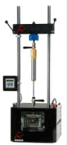

**Figure 3.1: Test model using velocity transducer**

This manufacturer’s standard dynamometers run at test speeds of 38-90 inches/second. A newer generation machine - the EMA - is capable of speeds over 4 meters/second. With help from our LVTs, these systems go a long way in improving ride quality in a passenger vehicle or helping a crew chief win a race.

The following graphs can be seen after the completion of the test

* Force vs. Velocity (hysteresis)
* Force vs. Displacement.

**3.2. Hydraulically Operated Shock Absorber Testing Machine**

Dampening force of a shock absorber is directly proportional to velocity and this parameter needs to be precisely controlled. A small variation of 1mm in a stroke of 100mm for 100rpm can result in a variation of 10% in dampening force.

A signal equivalent to frequency (rpm) and amplitude (displacement) is created in a Function generator which is fed to the P.I.D. controller. Machine response signal is also fed to the P.I.D controller. The error signal between the two signals creates differential pressure resulting in the movement of the actuator corresponding to programmed frequency and amplitude thereby completing the close loop. The variation is not more than 1% which can never be achieved with the conventional cam mechanism.

A typical test set up comprises of –

• Computerized display and control unit

• Power pack with heat exchanger

• Module with servo valve, high pressure filter, gas filled accumulators

• Load frame with side jacks for day light adjustment. /Actuator

• Universal type load-cell.



**Figure 3.2: Hydraulically Operated Shock Absorber Testing Machine**

**CHAPTER NO.04**

**CONSTRUCTION AND WORKING**

**4.1 CONTRUCTION:**

Shock absorber test rig is used to test the performance of various shock absorbers. Various part of the experimental setup has following components as shown in figure;

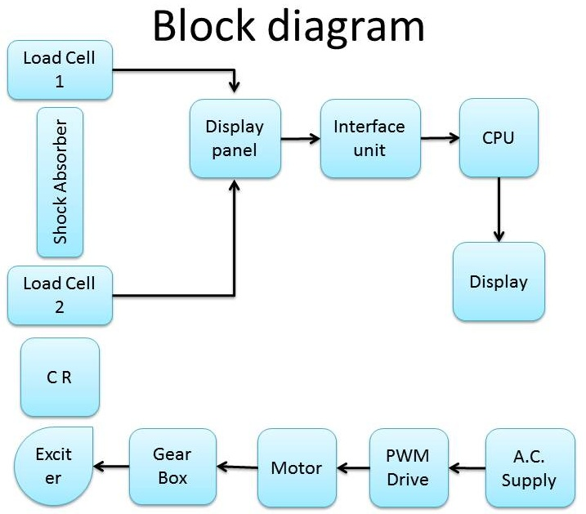

**Figure 4.1: Block diagram of test setup**

1. PWM Drive
2. D.C. Motor
3. Coupling
4. Gearbox
5. Exciter unit
6. Load cell
7. Shock absorber
8. PWM Drive:

Generally rectifier is used to convert AC power supply to DC output. But to obtain various range of DC output PWM drive is used in industries. It’s a commonly used technique for controlling power to inertial electrical devices made practical by using modern electronic power switches.

1. D.C Motor:

D.C Motor works on D.C. power supply and due to its some important advantages it is used for different applications such as it can be run at different speed and it has large stating torque. The motor used is PMDC (*Permanent Magnet Direct Current*). The motor has operating speed of 1500 rpm and is selected upon force transmission capacity. The motor is foot mounted.

1. Coupling :

A coupling is a mechanical element used to connect two shafts of transmission system. It connects different units of system like electric motor and input shaft of gear box. Lovejoy coupling has more advantage due to its cost effectiveness and flexibility.

1. Gear box:

Gear box is a mechanical device used for transmitting power from the prime mover to the machine with:

1. Change in torque and speed; or/and
2. Change in orientation of drive.

Depending upon the application worm gear is used in this setup due to large reduction ratio.

1. Exciter unit:

It is an element which is used to transmit force to the required component. As per our application we need a sinusoidal exciting unit which can be obtained by using eccentric cam along with connecting rod.

1. Load cell:

A load cell is a transducer that is used to measure a force by converting it into electrical signal. This conversion is indirect and happens in two stages. Through a mechanical arrangement, the force being sensed by deforming a strain gauge. The strain gauge measures the deformation (strain) as an electrical signal, because the strain changes the effective electrical resistance of the wire.

1. Shock absorber:

A shock absorber is a mechanical device designed to damp shock impulse, and dissipate kinetic energy. It is a dashpot type of absorber.

**4.2 WORKING:**

As shown in above block diagram the experimental setup is assembled. The input supply to the setup is given by A.C. supply. This supply is then converted to D.C. supply through PWM drive. The supply is regulated and supplied to motor by adjusting potentiometer. The power is transmitted from motor to gear box through coupling.

Gear box then drives the exciter and this drives the cam and thus rotating motion is converted to reciprocating motion. This force is then transmitted to load cell 2 and then to shock absorber. One side of shock absorber is attached to load cell 1 which is fixed to frame.

The readings from load cell are taken with the help of control system through amplifiers and then required data is transferred to the computer and displayed on the screen with the help of GUI (Graphic user interface) using Visual Basic.

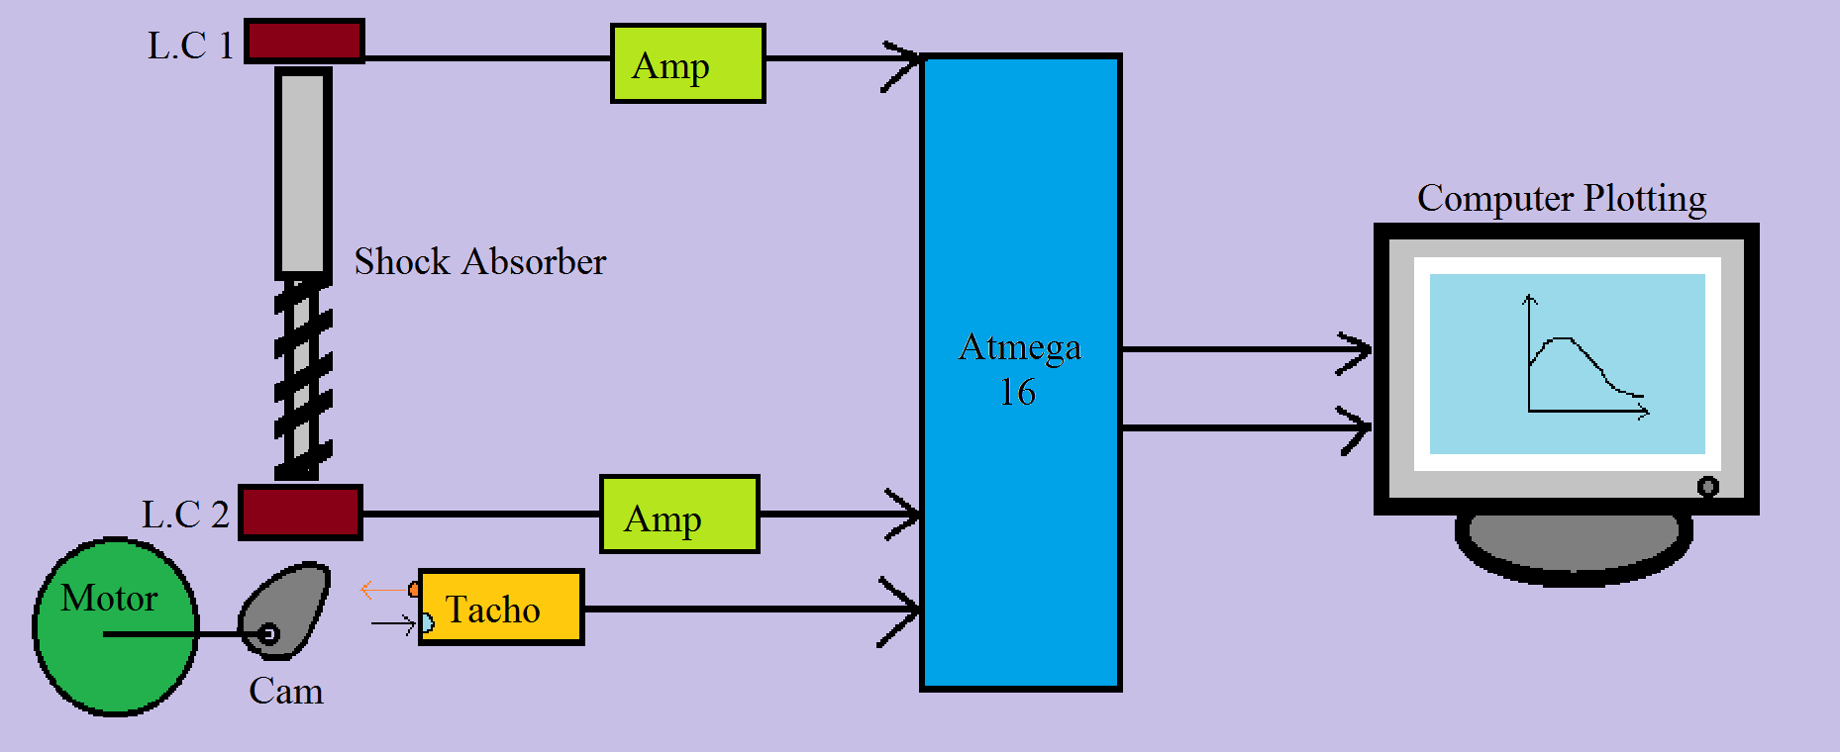

**Figure 4.2: Structural diagram of setup**

**CHAPTER NO.05**

**DESIGN**

**5. DESIGN**

**5.1 Motor Selection**

* + Type = PMDC
  + Power = 0.5HP
  + Speed = 1500 rpm (Synchronous)
  + Current = 2.5 AMP
  + Torque = 24 kg-cm
  + TEFC Construction ( *Totally Enclosed Fan-Cooled*)
  + Foot mounted

**5.2 Design of Worm Gear Box**

* Required output = 95 rpm
* Gear ratio = 15.5
* Designation = 2/31/10/2

**5.3 Design of Shaft**

**5.3.1 Worm**

* Torque on worm = 2237.34 N-mm
* Diameter = 20mm
* Material = PCS C45
* UTS = 630 N/mm2
* Yield Strength = 380 N/mm2

**5.3.2 Worm gear**

* Torque on gear = 4954.11 N-mm
* Diameter = 22mm
* Material = PCS C45
* UTS = 630 N/mm2
* Yield Strength = 380 N/mm2

**5.4 Design of Lovejoy Coupling**

* Designation = L-075
* Outside diameter = 38mm
* Inside diameter = 20mm
* Material = Cast Iron
* UTS = 480 N/mm2
* Yield Strength = 220 N/mm2

**5.5 Design of Key**

* Height = Width = 6mm
* Length of 20mm shaft = 20mm
* Length of 22mm shaft = 30mm

**5.6 Selection of Electronic Components**

**5.6.1 Load Cell**

Model CZL601 is selected whose data sheet is shown below:

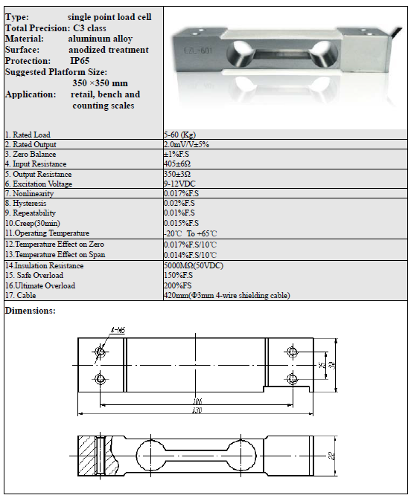

**Figure 5.1: CZL601 Specification sheet**

**5.6.2 RS-232 COM Port**

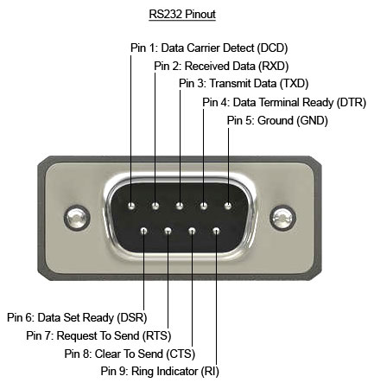

**Figure 5.2: A**[**DB**](http://en.wikipedia.org/wiki/D-subminiature)**-25 connector as described in the RS-232 standard**

In [telecommunications](http://en.wikipedia.org/wiki/Telecommunications), RS-232 is the traditional name for a series of standards for [serial](http://en.wikipedia.org/wiki/Serial_communication) binary [single-ended](http://en.wikipedia.org/wiki/Single-ended_signaling) [data](http://en.wikipedia.org/wiki/Data_transmission) and [control](http://en.wikipedia.org/wiki/Signaling_(telecommunications)) signals connecting between *DTE* ([*data terminal equipment*](http://en.wikipedia.org/wiki/Data_terminal_equipment)) and *DCE* ([*data circuit-terminating equipment*](http://en.wikipedia.org/wiki/Data_circuit-terminating_equipment), originally defined as *data communication equipment*). It is commonly used in [computer](http://en.wikipedia.org/wiki/Computer) [serial ports](http://en.wikipedia.org/wiki/Serial_port). The standard defines the electrical characteristics and timing of signals, the meaning of signals, and the physical size and [pin out](http://en.wikipedia.org/wiki/Pinout) of connectors.

The current version of the standard is *TIA-232-F Interface Between Data Terminal Equipment and Data Circuit-Terminating Equipment Employing Serial Binary Data Interchange*, issued in 1997.An RS-232 [serial port](http://en.wikipedia.org/wiki/Serial_port) was once a standard feature of a [personal computer](http://en.wikipedia.org/wiki/Personal_computer), used for connections to [modems](http://en.wikipedia.org/wiki/Modem), [printers](http://en.wikipedia.org/wiki/Printer_(computing)), [mice](http://en.wikipedia.org/wiki/Mouse_(computing)), data storage, [uninterruptible power supplies](http://en.wikipedia.org/wiki/Uninterruptible_power_supplies), and other peripheral devices.

However, the low transmission speed, large voltage swing, and large standard connectors motivated development of the [Universal Serial Bus](http://en.wikipedia.org/wiki/Universal_Serial_Bus), which has displaced RS-232 from most of its peripheral interface roles. Many modern personal computers have no RS-232 ports and must use either an external USB-to-RS-232 converter or an internal expansion card with one or more serial ports to connect to RS-232 peripherals. RS-232 devices are still found, especially in industrial machines, networking equipment, and scientific instruments.

* + - 1. **Scope of Standard**

The [Electronic Industries Association](http://en.wikipedia.org/wiki/Electronic_Industries_Alliance) (EIA) standard RS-232-Cas of 1969 defines:

* Electrical signal characteristics such as voltage levels, [signalling rate](http://en.wikipedia.org/wiki/Data_signaling_rate), timing and [slew-rate](http://en.wikipedia.org/wiki/Slew_rate) of signals, voltage withstand level, [short-circuit](http://en.wikipedia.org/wiki/Short_circuit) behaviour, and maximum load [capacitance](http://en.wikipedia.org/wiki/Capacitance)
* Interface mechanical characteristics, pluggable connectors and pin identification
* Functions of each circuit in the interface connector
* Standard subsets of interface circuits for selected telecom applications

The standard does not define such elements as the [character encoding](http://en.wikipedia.org/wiki/Character_encoding) or the framing of characters, or error detection protocols. Details of character format and transmission bit rate are controlled by the serial port hardware, often a single [integrated circuit](http://en.wikipedia.org/wiki/Integrated_circuit) called a [UART](http://en.wikipedia.org/wiki/UART) that converts data from parallel to [asynchronous start-stop](http://en.wikipedia.org/wiki/Asynchronous_start-stop) serial form. Details of voltage levels, slew rate, and short-circuit behaviour are typically controlled by a [line driver](http://en.wikipedia.org/wiki/Line_driver) that converts from the UART's [logic levels](http://en.wikipedia.org/wiki/Logic_level) to RS-232 compatible signal levels, and a receiver that converts RS-232 compatible signal levels to the UART's logic levels. The standard does not define bit rates for transmission, except that it says it is intended for [bit rates](http://en.wikipedia.org/wiki/Bit_rate) lower than 20,000 bits per second. Many modern devices support speeds of 115,200 bit/s and above.

**5.6.2.2 Standard details**

In RS-232, user data is sent as a [time-series](http://en.wikipedia.org/wiki/Time-series) of [bits](http://en.wikipedia.org/wiki/Bit). Both synchronous and asynchronous transmissions are supported by the standard. In addition to the data circuits, the standard defines a number of control circuits used to manage the connection between the DTE and DCE. Each data or control circuit only operates in one direction, which is, signalling from a DTE to the attached DCE or the reverse. Since transmit data and receive data are separate circuits, the interface can operate in a [full duplex](http://en.wikipedia.org/wiki/Full_duplex) manner, supporting concurrent data flow in both directions. The standard does not define character framing within the data stream, or character encoding.

**5.6.3 Atmel ATmega16**

The ATmega16 is a low-power CMOS 8-bit microcontroller based on the AVR enhanced RISC architecture. By executing powerful instructions in a single clock cycle, the ATmega16 achieves Throughputs approaching 1 MIPS per MHz allowing the system designed to optimize power consumption versus processing speed.

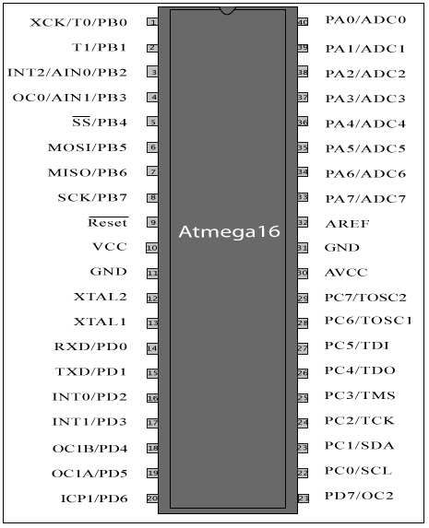

**Figure 5.3: ATmega16 Pin Configuration**

The AVR core combines a rich instruction set with 32 general purpose working registers. All the 32 registers are directly connected to the Arithmetic Logic Unit (ALU), allowing two independent registers to be accessed in one single instruction executed in one clock cycle. The resulting architecture is more code efficient while achieving throughputs up to ten times faster than conventional CISC microcontrollers.

The ATmega16 provides the following features: 16K bytes of In-System Programmable Flash Program memory with Read-While-Write capabilities, 512 bytes EEPROM, 1K byte SRAM, 32 general purpose I/O lines, 32 general purpose working registers, a JTAG interface for Boundary scan,

On-chip Debugging support and programming, three flexible Timer/Counters with compare modes, Internal and External Interrupts, a serial programmable USART, a byte oriented Two-wire Serial Interface, an 8-channel, 10-bit ADC with optional differential input stage with programmable gain (TQFP package only), a programmable Watchdog Timer with Internal Oscillator, an SPI serial port, and six software selectable power saving modes. The Idle mode stops the CPU while allowing the USART, Two-wire interface, A/D Converter, SRAM; Timer/Counters, SPI port, and interrupt system to continue functioning. The Power-down mode saves the register contents but freezes the Oscillator, disabling all other chip functions until the next External Interrupt or Hardware Reset. In Power-save mode, the Asynchronous Timer continues to run, allowing the user to maintain a timer base while the rest of the device is sleeping. The ADC Noise Reduction mode stops the CPU and all I/O modules except Asynchronous Timer and ADC, to minimize switching noise during ADC conversions. In Standby mode, the crystal/resonator Oscillator is running while the rest of the device is sleeping. This allows very fast start-up combined with low-power consumption. In Extended Standby mode, both the main Oscillator and the Asynchronous Timer continue to run.

The device is manufactured using Atmel’s high density non-volatile memory technology. The On chip ISP Flash allows the program memory to be reprogrammed in-system through an SPI serial interface, by a conventional non-volatile memory programmer, or by an On-chip Boot program running on the AVR core. The boot program can use any interface to download the application program in the Application Flash memory. Software in the Boot Flash section will continue to run while the Application Flash section is updated, providing true Read-While-Write operation. By combining an 8-bit RISC CPU with In-Programmable Flash on a monolithic chip, the Atmel ATmega16 is a powerful microcontroller that provides a highly-flexible and cost-effective solution to many embedded control applications.

The ATmega16 AVR is supported with a full suite of program and system development tools including: C compilers, macro assemblers, program debugger/simulators, in-circuit emulators, and evaluation kits.

* 1. **Design of Circuit and Interfacing**

**5.7.1 Main Circuit**

Circuit has been designed such that real-time plot of transmissibility vs. frequency ratio is obtained on a graph in Visual Basic. The rating of the load cell is 2mV/V, with a maximum load of 80kg.Hence the maximum voltage output of load-cell is 10mV with a supply of 5V. This voltage is given as a difference in the “Sense+” and “Sense-” terminals of the load-cell. The signals from both the load-cells are given to the ADC0 through ADC3 of the microcontroller. The voltage differences are processed and the transmissibility is directly fed to the COM-port for processing in Visual Basic.

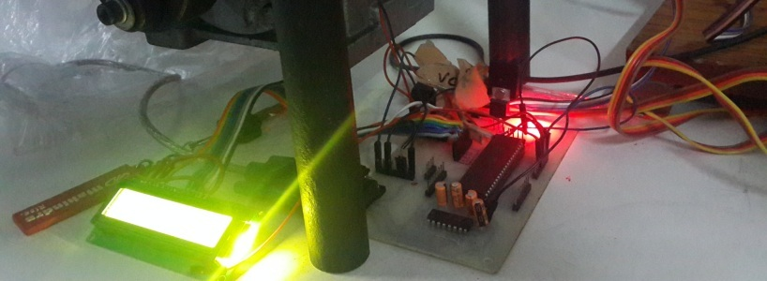

**Figure 5.4: Main PCB with LCD**

* + 1. **Tachometer**

The tachometer is made using a LDR (Light Dependent Resistor), connected in series with a 10k resistor. The VDC is given between the resistor and LDR, and the voltage output is measured from between them and fed to ADC4 of microcontroller. A laser is used as the light source, held in a custom-made adjustable holder. When light falls on the LDR, the voltage value increases and when the connecting rod cuts the light, the voltage value suddenly drops.

The no. of such drops is measured using a counter function in BASCOM. The sampling frequency is compared to real-time clock manually, and the value of angular frequency is calculated by the microcontroller according to formula. This value is sent along with the transmissibility output to the COM port for plotting in Visual Basic.

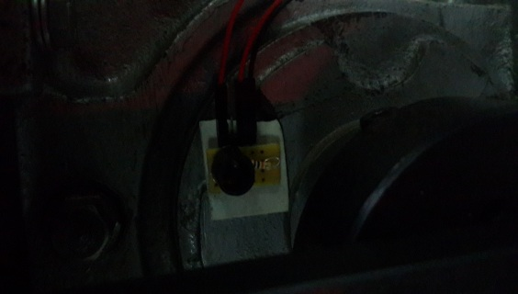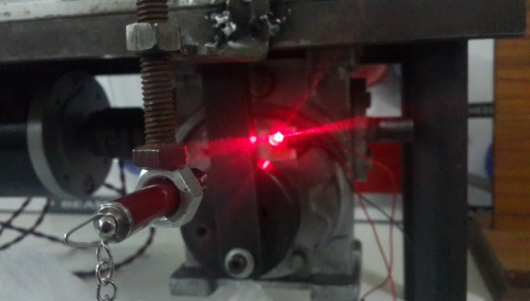

**Figure 5.5: LDR circuit with LASER light source**

**CHAPTER NO.06**

**MODELLING**

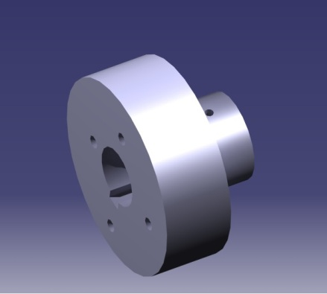 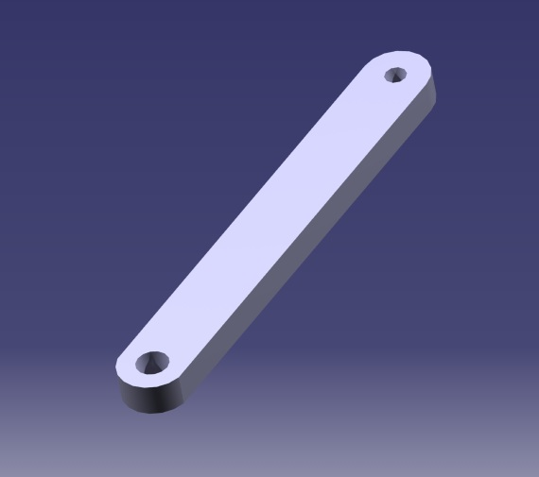 **Figure 6.1: Cam** **Figure 6.2: Connecting Rod**

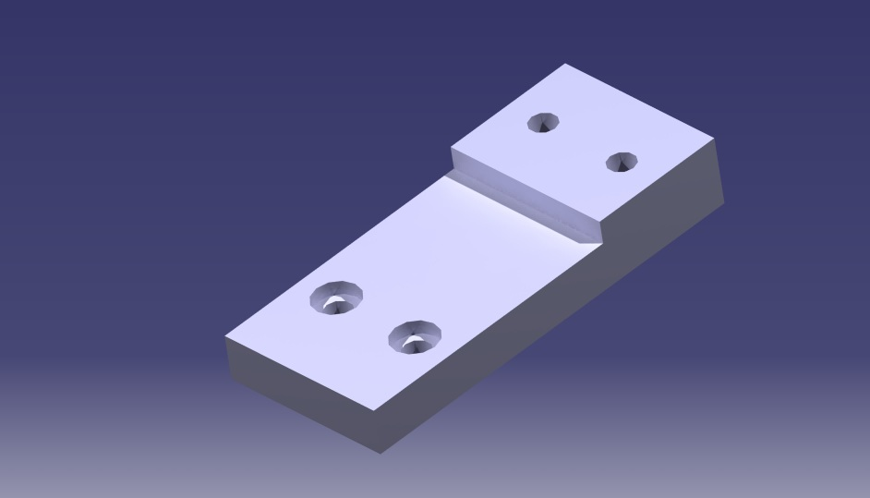

**Figure 6.3: S-Frame**

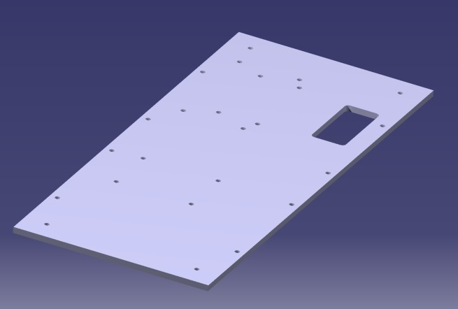

**Figure 6.4: Base-Plate**

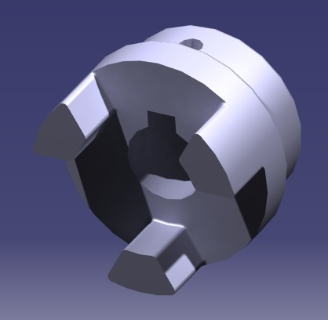

**Figure 6.5: Lovejoy Coupling**

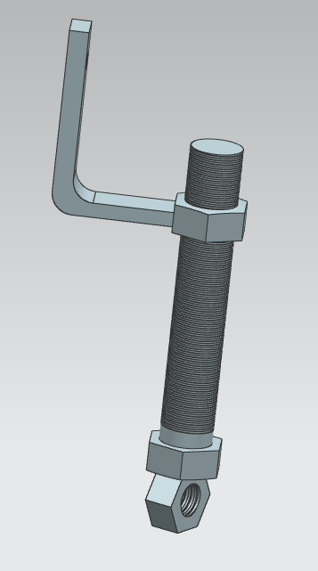

**Figure 6.6: Laser Holder**

**CHAPTER NO.07**

**BILL AND COSTING OF MATERIALS**

**7.1 BILL OF MATERIALS**

|  |  |  |  |
| --- | --- | --- | --- |
| **Sr. No** | **Part Description** | **Quantity** | **Material** |
| 1. | Eccentric Cam | 1 | EN24 |
| 2. | Connecting Rod | 1 | EN24 |
| 3. | S-Frame | 3 | EN24 |
| 4. | C-Clamp | 2 | EN24 |
| 5. | Slider | 1 | EN24 |
| 6. | Guide Way A | 2 | EN24 |
| 7. | Guide Way B | 2 | EN24 |
| 8. | Love-Joy Coupling | 1 | EN24 |
| 9. | Frame/Support | - | EN24 |
| 10. | Motor | 1 | STD |
| 11. | Gear Box | 1 | STD |
| 12. | Shock Absorber | 1 | STD |
| 13. | Load Cell | 2 | STD |
| 14. | PWM Drive | 1 | STD |
| 15. | Interfacing Unit | 1 | STD |
|  |  |  |  |
|  |  |  |  |
|  |  |  |  |

**7.2 COST-REPORT**

**7.2.1 Raw Material Cost**

The total raw material cost as per the individual material and their corresponding rates per kg is as follows:

|  |  |  |  |  |
| --- | --- | --- | --- | --- |
| **Sr. No** | **Material** | **Quantity (Kg)** | **Rate per Kg** | **Cost** |
| 1. | EN24 | 45 | 125 | 5625 |

**7.2.2 Machining Cost**

|  |  |  |  |
| --- | --- | --- | --- |
| **Operation** | **Rate (Rs./Hr.)** | **Total Time (Hrs.)** | **Total Cost (Rs.)** |
| Lathe | 120 | 3.8 | 456 |
| Milling | 180 | 11.66 | 2100 |
| Drilling | 80 | 4.5 | 360 |
| VMC | 250 | 6 | 1500 |
| Tapping | 5 Rs/Hole | 80 Holes | 400 |
| Total | | | 4815 |

**7.2.3 Miscellaneous Cost**

|  |  |
| --- | --- |
| **Operation** | **Cost (Rs.)** |
| Bending | 200 |
| Gas Cutting | 200 |
| Painting & blackodising | 300 |
| Total | 700 |

**7.2.4 Cost of Purchased Parts**

|  |  |  |  |
| --- | --- | --- | --- |
| **Sr. No** | **Description** | **Quantity** | **Cost** |
| 1. | DC Motor (0.5 HP) | 1 | 5500 |
| 2. | Worm Gear Box | 1 | 4500 |
| 3. | Shock Absorber | 1 | 150 |
| 4. | Allen Bolts, Nut & Bolts, Washers | - | 500 |
| 5. | Others | - | 250 |
| Total | | | 10900 |

**7.2.5 Cost of Electronic Items**

|  |  |  |  |
| --- | --- | --- | --- |
| **Sr. No.** | **Description** | **Quantity** | **Cost** |
| 1. | Load-cell (CZL-601AA) | 2 | 700 |
| 2. | ATmega16 | 2 | 350 |
| 3. | RS-232 cable | 1 | 200 |
| 4. | PCB printing | 1 | 100 |
| 5. | Miscellaneous (jumpers, resistors, switches etc.) | - | 1100 |
| 6. | 12VDC power adapter | 1 | 60 |
| Total | | | 2510 |

**7.3 Total Cost**

Total Cost = Raw Material Cost + Machining Cost + Miscellaneous Cost + Cost of

Purchased Parts + Cost of Electronic Items

= 5625 + 4815 + 700 + 10900 + 2510

= Rs. 24550/-

The total cost of the setup is twenty four thousand five hundred and fifty rupees only.

**CHAPTER NO.08**

**RESULTS**

**8. RESULTS**

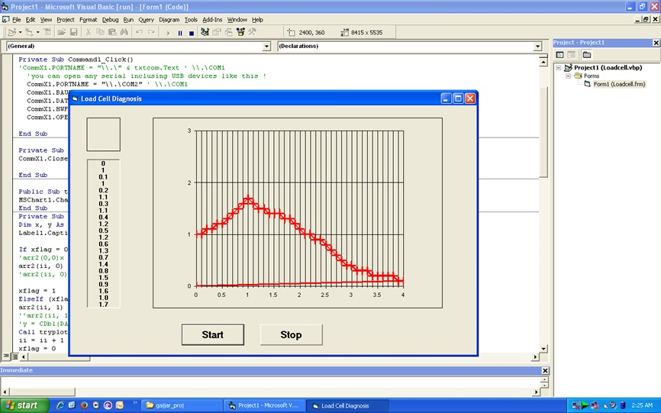

**Figure 8.1: Plot of transmissibility vs. frequency ratio in VB**

Hence the damping curve of the shock-absorber is obtained. This curve can be studied easily to find out the damping ratio of the shock-absorber.

Over time, the damping fluid of the shock-absorber becomes viscous and the springs tend to become stiff. Studying this curve, and knowing the natural frequency of the system, damping ratio can be calculated. Hence, it can be used to find out whether a shock-absorber needs replacement, and also to analyse the general performance characteristics of the shock-absorber.

**CHAPTER NO.09**

**CONCLUSION**

**9. CONCLUSION**

The performance characteristics of tested shock-absorber are obtained by using the testing set-up, and matching with the ideal performance characteristics.

With the help of this experimental set-up we obtain various damping characteristics of different shock-absorbers:

1. For damping ratio (ζ) = 1.0 of selected shock-absorber, force transmissibility vs. frequency ratio is within limit.
2. At four different amplitudes, shock-absorber damping ratio and force transmissibility curve are obtained, which are matched with theoretical ideal characteristics curves of shock-absorber.
3. The natural frequency of the shock-absorber can be obtained by using the plot of real-time data obtained, and observing where the transmissibility value is unity again, as ($\frac{ω}{ω_{n}}$) = √2 at that point.

Hence, the result obtained by the automated shock-absorber testing set-up, and plotting it in Visual Basic, is satisfactory and effective to achieve the objective of technical and quantitative performance analysis of shock-absorber.

**CHAPTER NO.10**

**PRESENT APPLICATION AND FUTURE SCOPE**

**10.1 PRESENT APPLICATION**

By using shock absorber testing machine we can find force transmitted, force impressed and frequency. This enables us to plot graph between transmissibility ratio and frequency. The graph can be plotted at different speed.

The type of excitation this setup is providing is sinusoidal due to reciprocating type of mechanism. The readings are obtained from load cell and then calibrated to find the desired output.

By analysing the graph obtained we can decide the application of the shock absorber. We can also test the given shock absorber which is already in use and find out whether it’s performing as it is supposed to be.

We find it very useful in Automobile industries for testing of shock absorber.

**10.2 FUTURE SCOPE**

Practically the shock obtained in practice absorbs shock in non-uniform manner. So in order to test the shock absorber we need to employ non uniform shocks on shock absorber which can be obtained from hydraulic exciter. We can also add the subsystem which can find the viscosity of damper oil at different temperature and the performance and reliability of system can be calculated. This can also give the operation range of the shock absorber.

**REFERENCES**

**REFERENCES**

1. “Machine Design Data” - Lingaiah; McGraw-Hill; 2004.
2. “Design Data” - Faculty of Mechanical Engg.; DPV Printers,2000.
3. “Shigley’s Mechanical Engineering Design” - Budynas−Nisbett; McGraw-Hill; Eighth Edition.
4. “Mechanical Vibrations” - S.S. Rao; Tata McGraw-Hill.
5. “Theory of Machines” - S.S. Ratan; Tata McGraw-Hill.
6. “<http://www.lovejoy-inc.com/products/jaw-type-couplings/l-type.aspx>”,

L-Type – Standard Jaw Coupling.

**APPENDIX**

**BASCOM-AVR code**